## Demo CRUD operations

### HttpMethod:Get

Route:api/v2/products

Description:Get All Products

URI Parameters:None

Body Parameters: None

HttpResponseStatusCode:200 OK

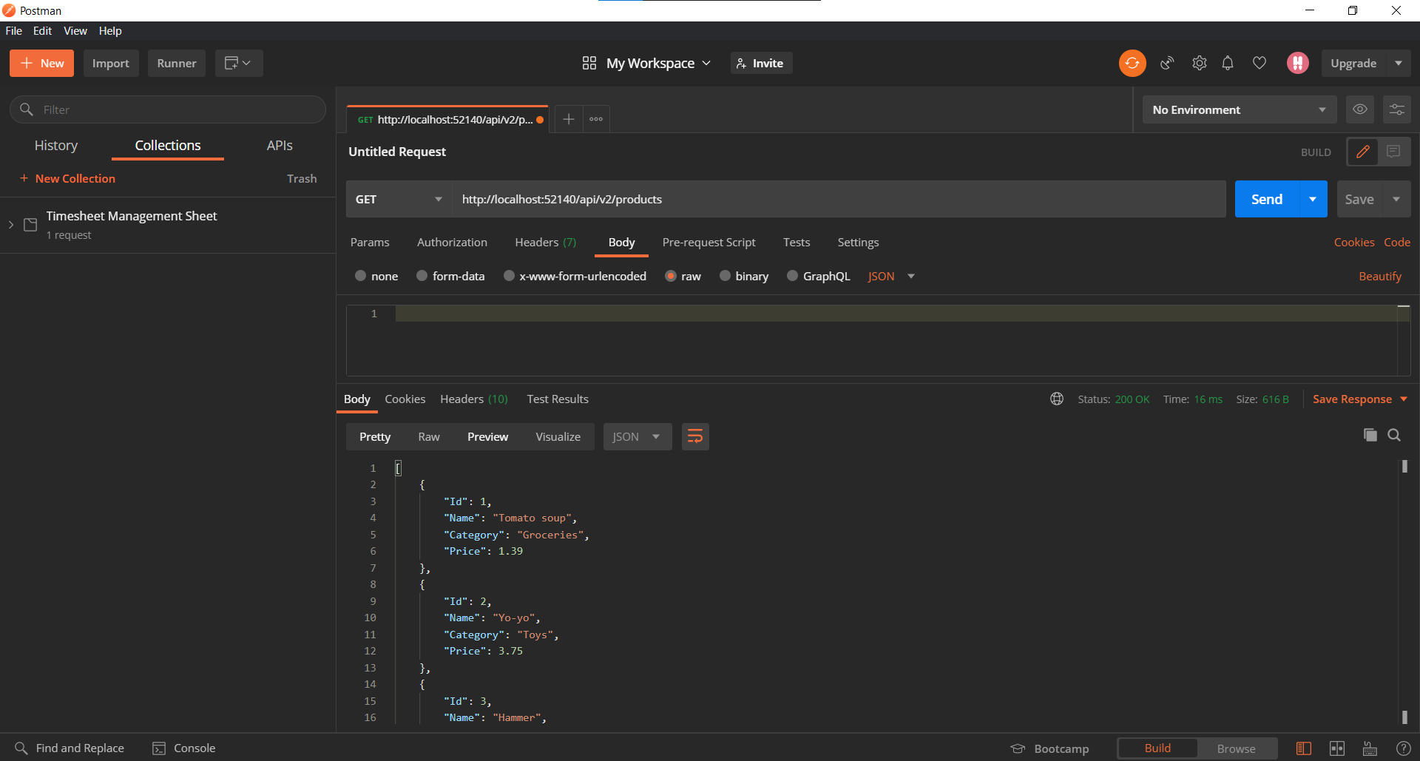

Route:api/v2/products?category=

Description:Get products by category

URI Parameters:category

Body Parameters: None

HttpResponseStatusCode:200 OK

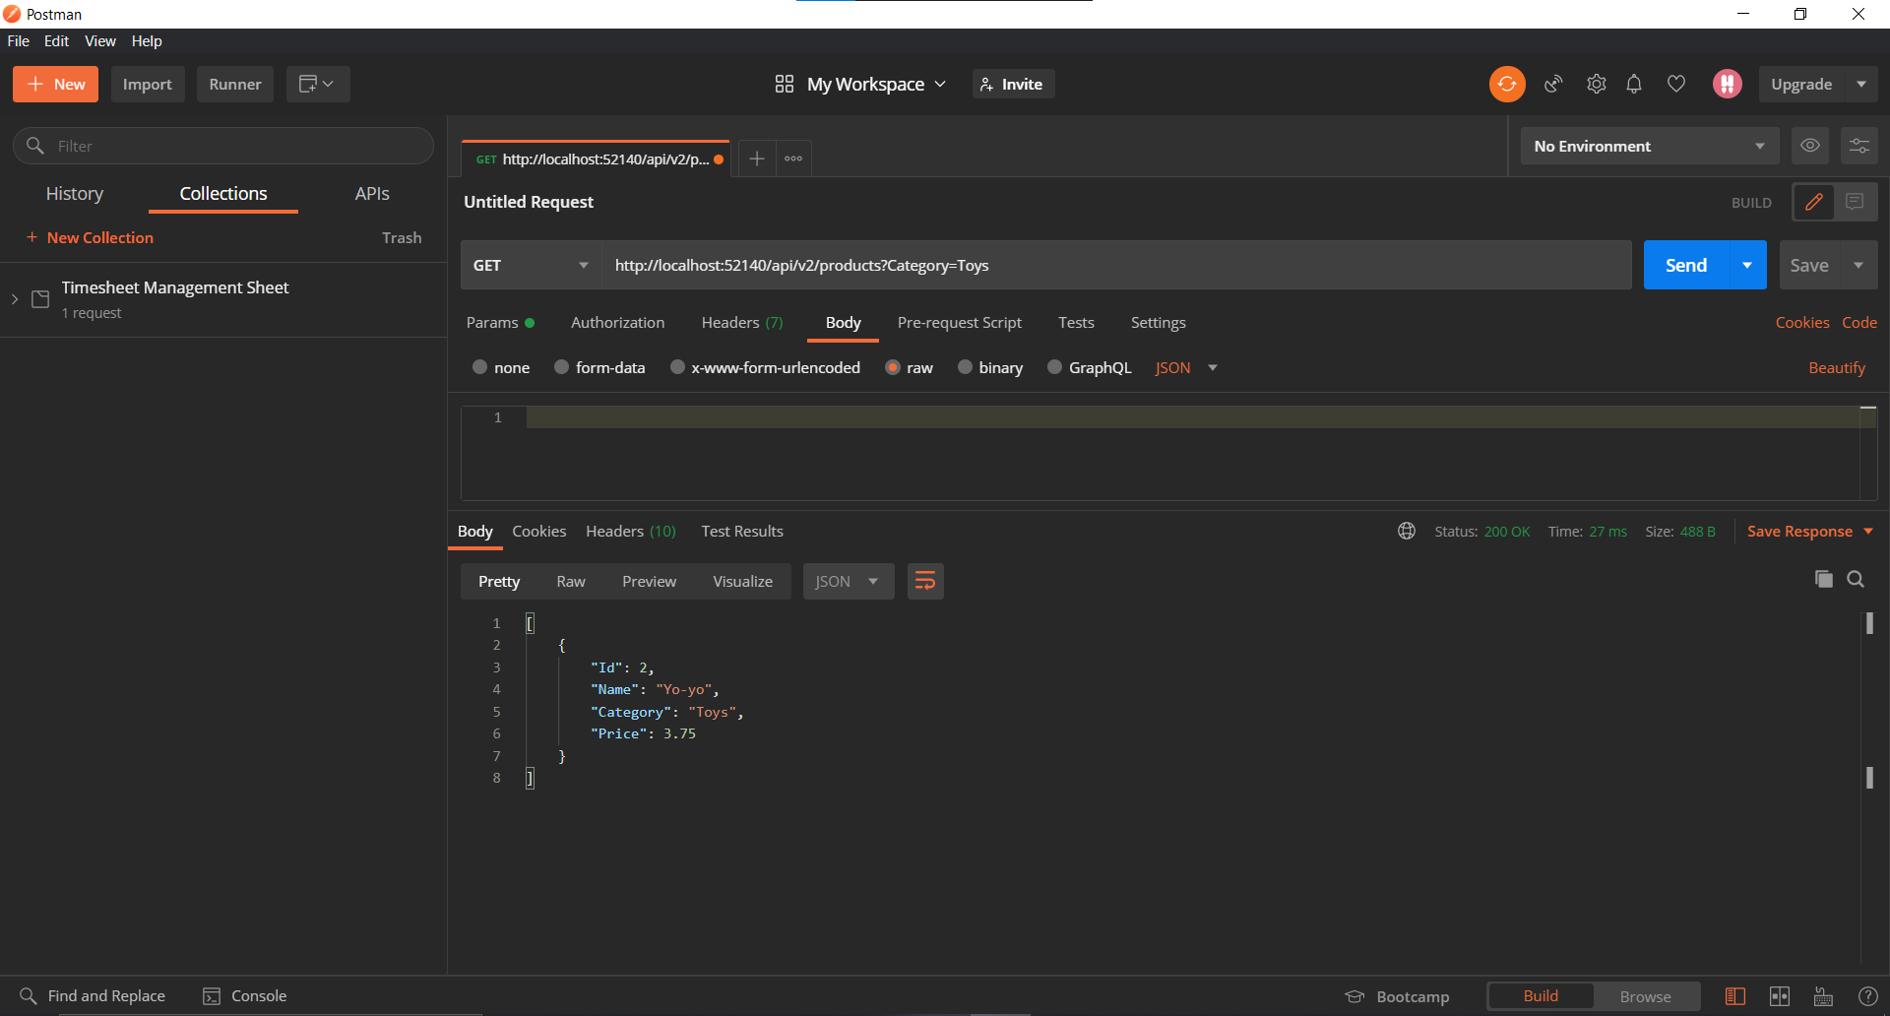

Route:api/v2/products/{productId}

Description:Get products by product id

URI Parameters:id

Body Parameters: None

HttpResponseStatusCode:200 OK

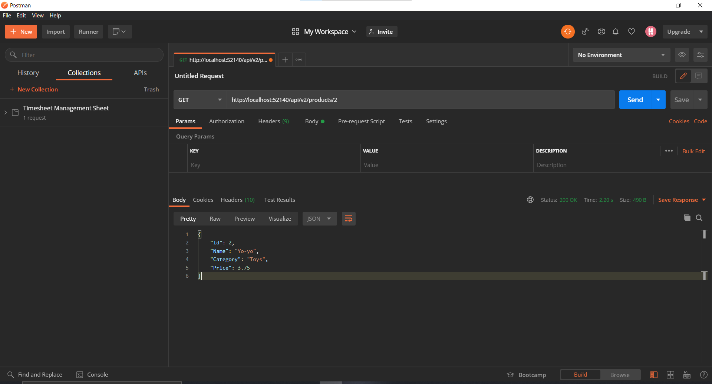

### HttpMethod:Post

Route:api/v2/products

Description:Post new product

URI Parameters:None

Body Parameters: Name,Category,Price

HttpResponseStatusCode:201 Created

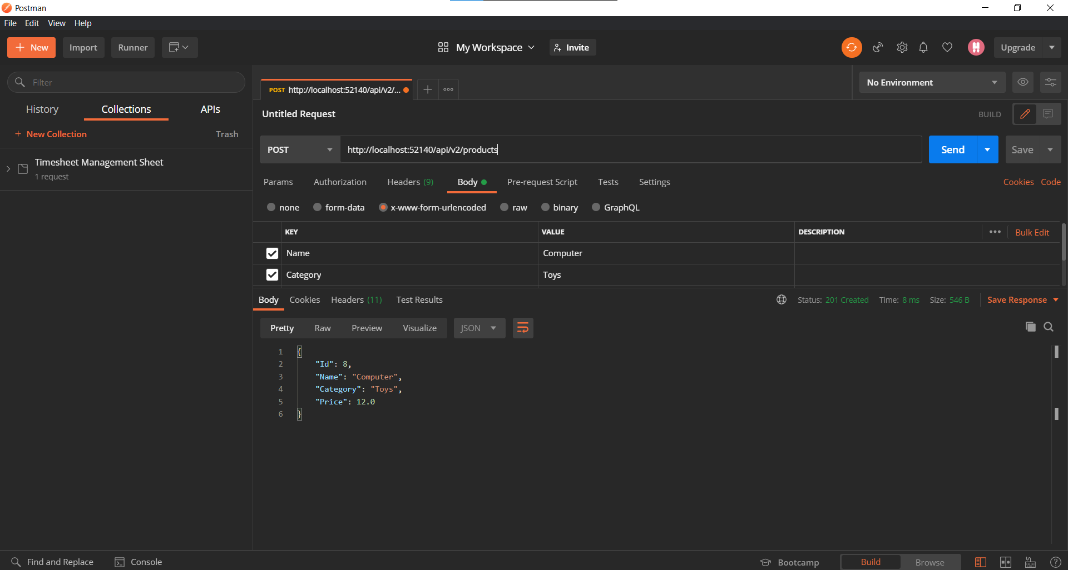

### 

### HttpMethod:Put

Route:api/v2/products/{id}

Description:Update a product

URI Parameters:id

Body Parameters: Name,Category,Price

HttpResponseStatusCode:200 OK

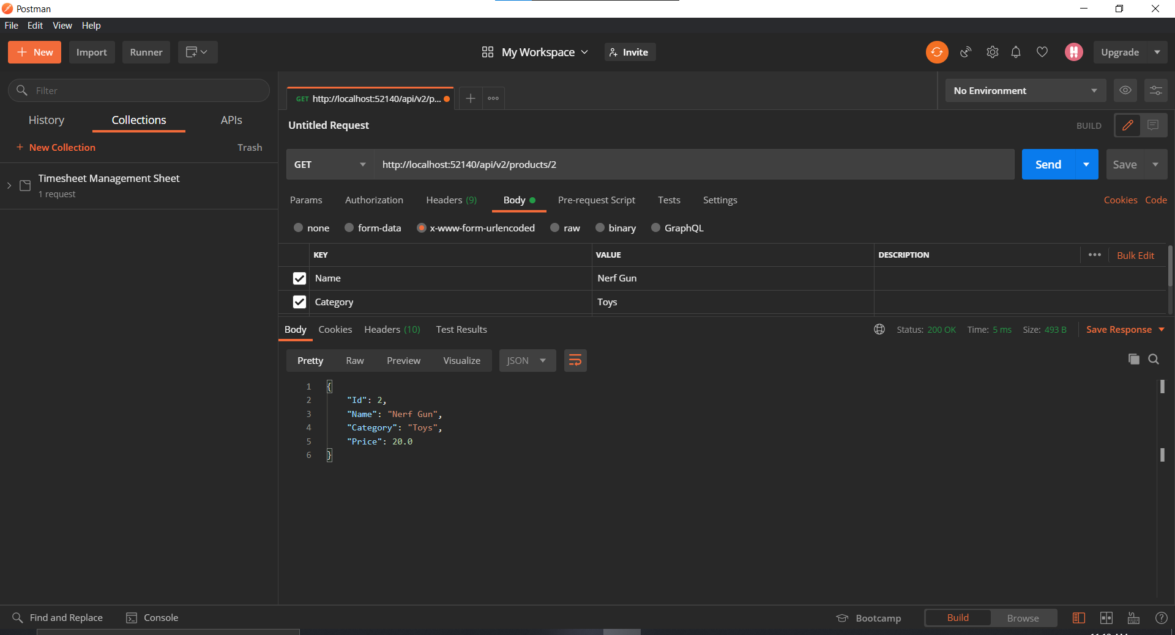

### 

### 

### 

### 

### 

### 

### 

### HttpMethod:Delete

Route:api/v2/products/{id}

Description:Delete a product

URI Parameters:id

Body Parameters: None

HttpResponseStatusCode:204 No Content

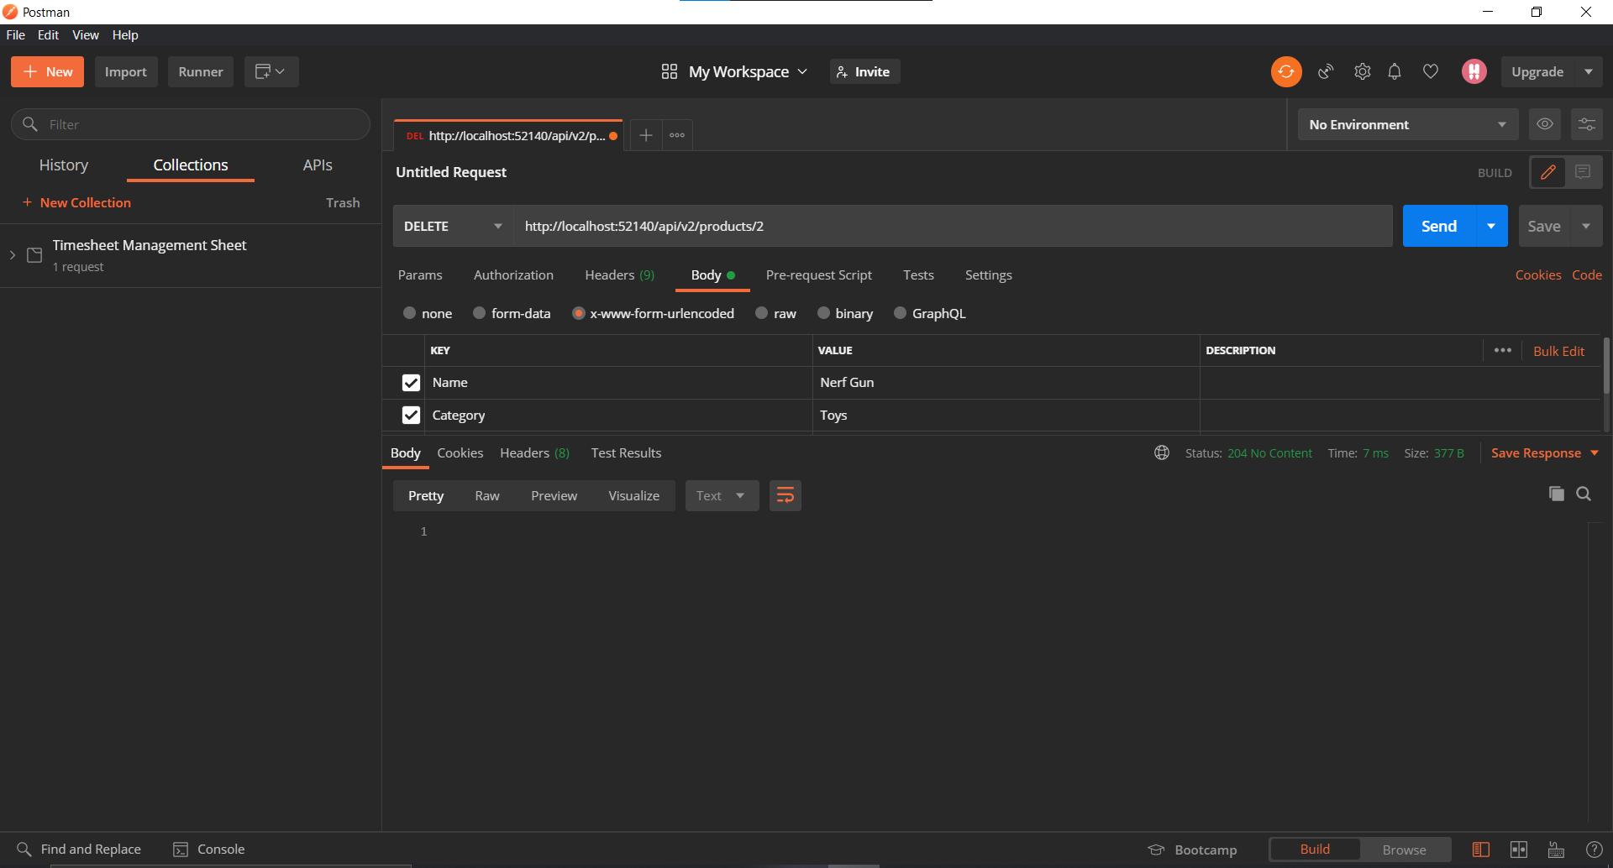

## Demo overposting & underposting handled and correct outcomes - POSTMAN

### Underposting

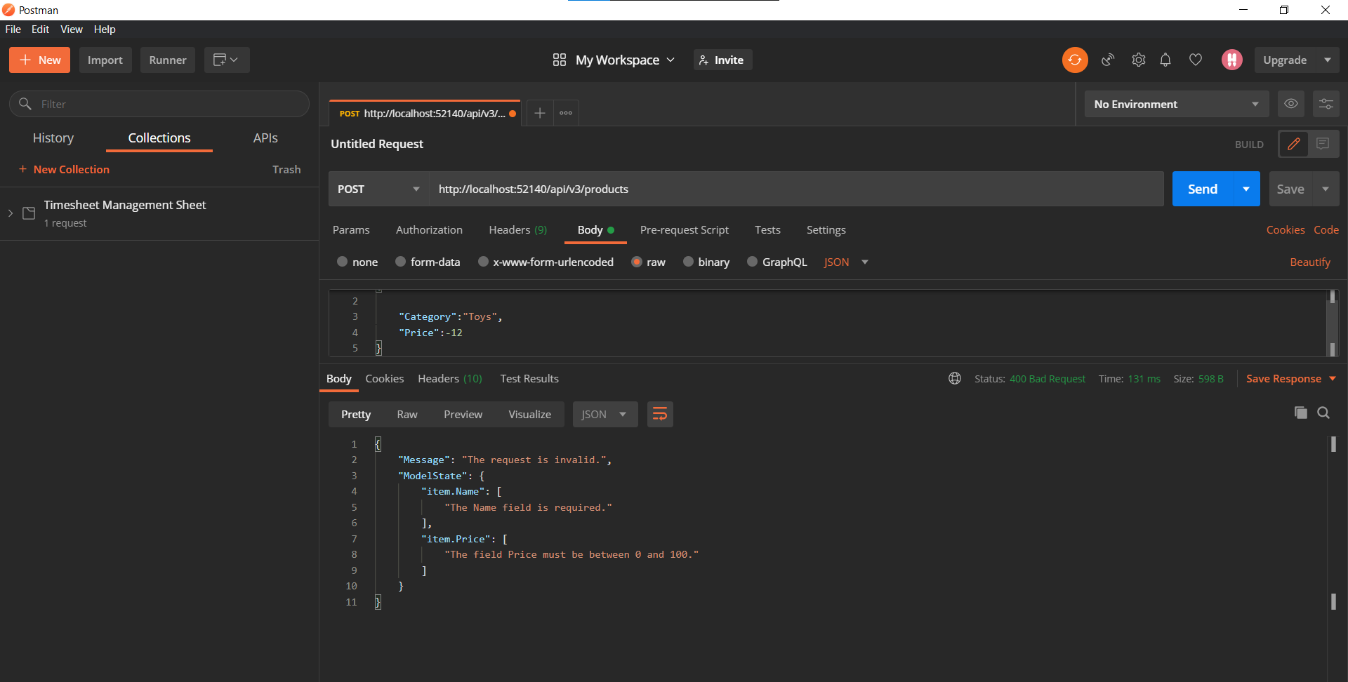

### Overposting

